| **Test Name** | | Update a Physician Record | | | |
| --- | --- | --- | --- | --- | --- |
| **Use Case Tested:** | | Use Case – Update a Physician Record | | | |
| **Test Description:** | | User finds a record entered for a Physician  User navigates to Search tab and selects Search Physician, or selects Search Physician button from welcome page  User is presented with a list of physician records  User searches for physician using Surname, First Name, or Provider Number  User selects record  User amends fields as required  User submits record | | | |
| **Pre-conditions** | | User must be logged in as an administrator  Physician records must exist | | | |
| **Post-conditions** | | The database is successfully updated with the new data for the Physician. | | | |
| **Notes:** | |  | | | |
| **Result (Pass/Fail/Warning/Incomplete)** | |  | | | |
|  | **TEST STEP** | | **EXPECTED TEST RESULTS** | P | F |
|  | User selects “Search > Search Physician” from the menu bar or selects Search Physician button on Admin Home page | | A list of physician records is returned – using tab  A list of physician records is returned – using button | X  X |  |
|  | User enters a search for a physician record | | Records meeting criteria are returned | X |  |
|  | User changes Surname | | Input does not show error | X |  |
|  | User changes First Name | | Input does not show error | X |  |
|  | User updates Provider Name | | Input does not show error | X |  |
|  | User updates Physician Comments | | Input does not show error | X |  |
|  | User selects Submit button | | Message appears that the record was successfully added | X |  |
|  |  | | Database updated to show new worker & related details | X |  |

|  |  |  |  |  |  |
| --- | --- | --- | --- | --- | --- |
| **Test Data Table** | | | | | |
|  | **1** | **2** | **3** | **4** | **5** |
| Test – 1 | Search = hous | Update record to make all records for Physician the same | Add a comment to one record |  |  |
| Test – |  |  |  |  |  |
| Test – |  |  |  |  |  |
|  |  |  |  |  |  |

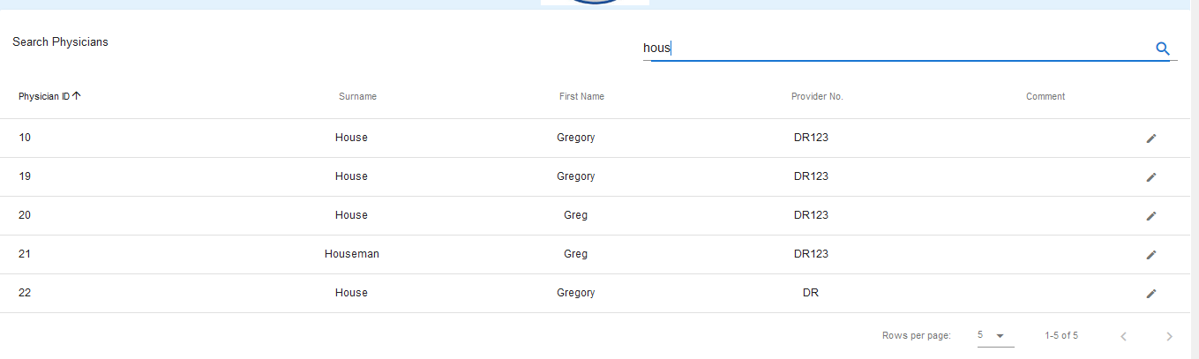

Search results for “hous”. Update ID 20 – first name to be Gregory. Update ID 21 – surname to be House, first name to be Gregory. Update ID 22 – provider number to be DR123. Update ID 22 to have a comment – “Update Physician Test”

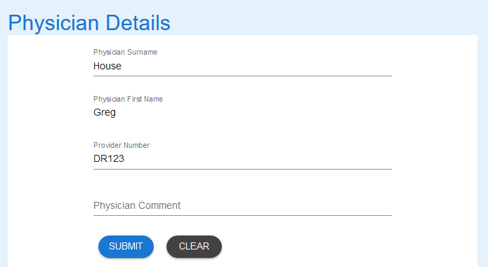

ID 20 selected and data uploaded into form.

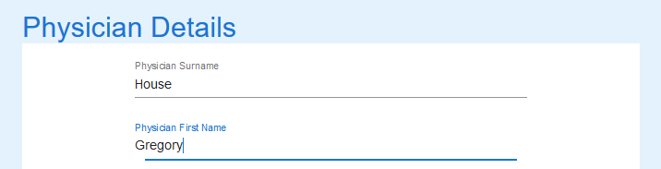

First name updated



Record submitted. Success message received

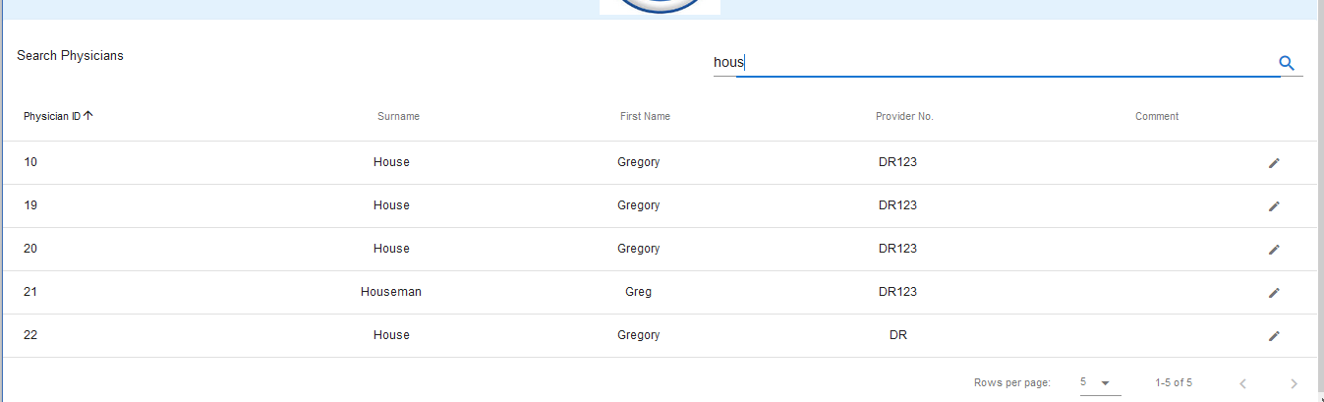

New search for “hous” shows ID 20 has been updated as expected.

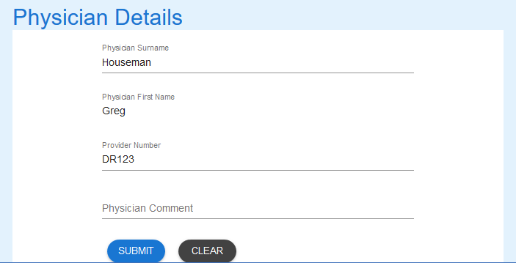

ID 21 Selected and record loaded successfully into form



Adding space to surname returns an error message as expected.



Surname updated.

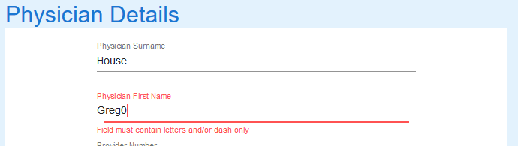

Entering a zero instead of the letter o has given an error as expected

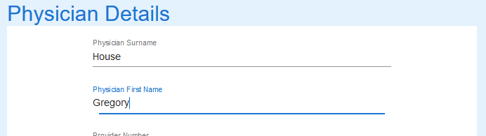

First name updated.



Submit button entered and success message received.

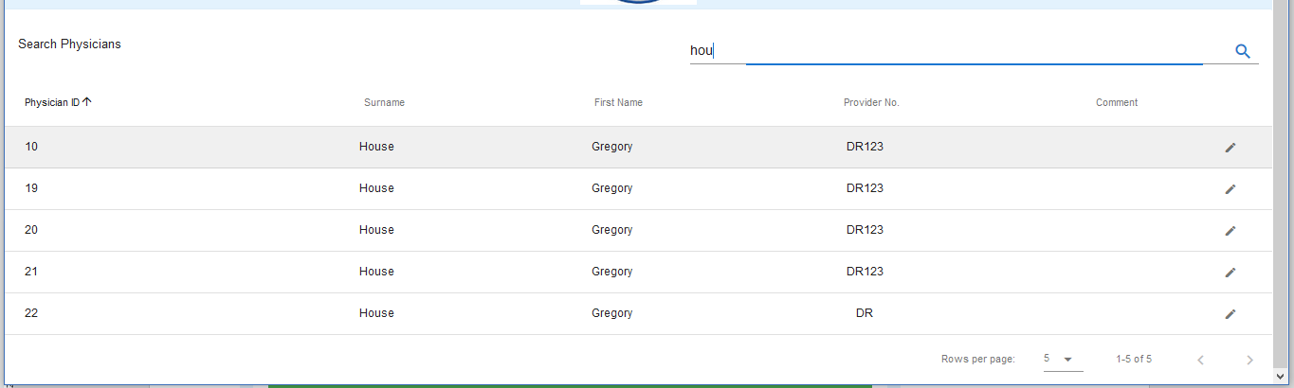

Search for “hou” shows ID 21 has been updated as expected.

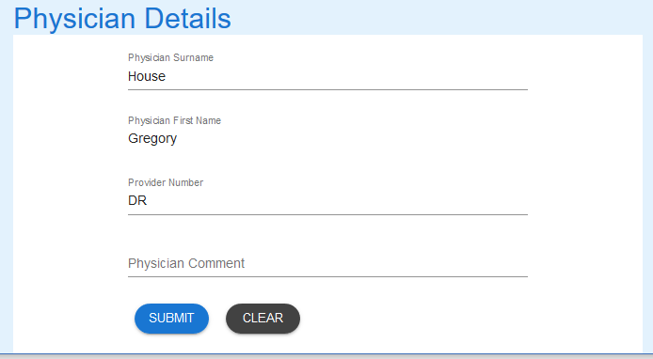

ID 22 selected and details updated into form



Adding a “-“ (dash) to the field has returned an error as expected.



Provider number updated

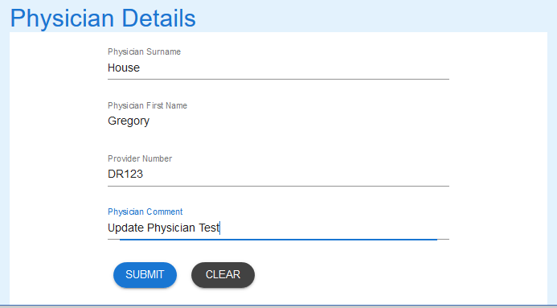

Comment added, and record has fields changed as required



Submit button selected and success message received

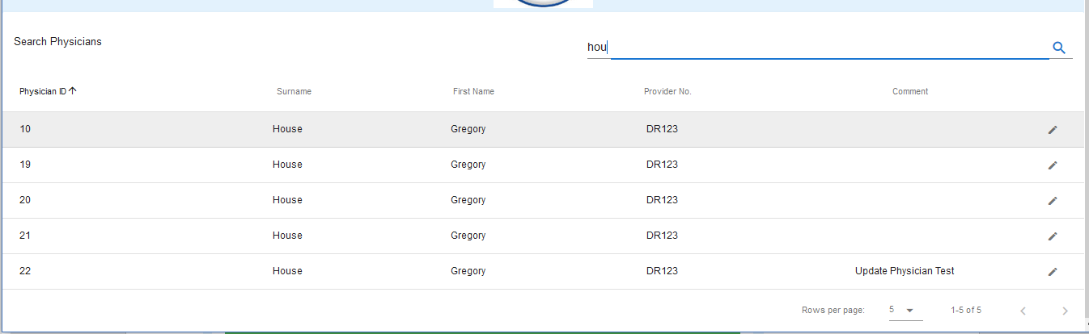

Final search for “hou”. All records for House have been updated as expected.